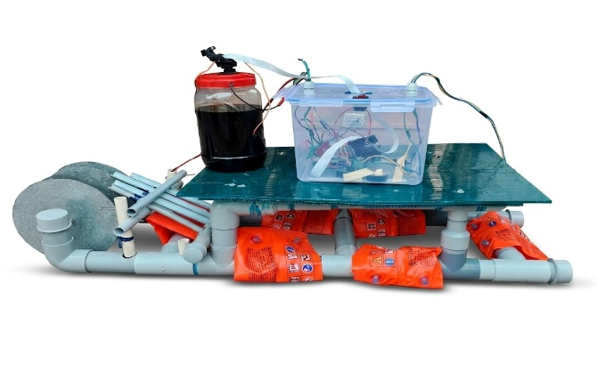
AI BASED OIL SPILL DETECTION AND CLEANUP USING AUTONOMOUS BOAT
 |  | 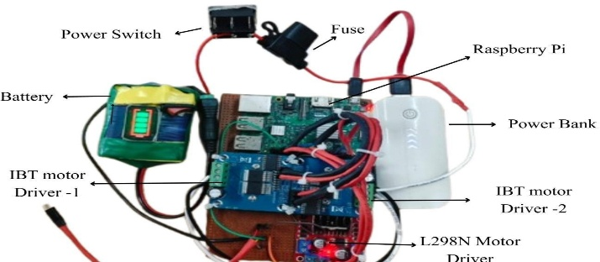
Abstract:
With increasing environmental pollution and frequent occurrences of oil spills in water bodies, there is a growing need for intelligent and cost-effective monitoring and cleanup solutions. Conventional oil spill management methods are largely dependent on human intervention, making the process time-consuming, unsafe, and inefficient in hazardous environments. This project presents the design and development of an autonomous surface vehicle for oil spill monitoring and assisted cleanup operations. The proposed system aims to minimize human involvement by integrating embedded control, propulsion mechanisms, and vision-based monitoring. The system is built around a Raspberry Pi as the onboard controller, which coordinates the movement and operation of the vehicle. Differential propulsion using DC motors enables smooth navigation over the water surface, while a dedicated roller mechanism assists in the collection or handling of floating pollutants. A pan–tilt camera module mounted on the vehicle provides adjustable visual coverage of the surrounding area, allowing real-time inspection without altering the direction of motion. Power is supplied through a single battery source, with regulated voltage distribution ensuring safe operation of both control and actuation units. The design focuses on achieving an optimal balance between torque and speed through appropriate motor and propeller selection, ensuring reliable performance with low power consumption. The modular architecture of the system allows easy expansion and future upgrades such as intelligent navigation and automated spill detection. This project demonstrates a practical approach toward autonomous water surface monitoring and serves as a foundation for advanced environmental protection systems.

Features:
- Reduced human intervention in hazardous environments
- Low-cost and scalable system architecture
- Autonomous water surface navigation
- AI based vision system for oil spill detection and tracking
- Efficient oil spill cleanup system
Project by | Project guide |  | Project Coordinator
Anandharaman V (22UEE005)  Raakesh K (22UEE065)  Sharan Kumar M (22UEE082)  Varunesh S (22UEE094) | Dr. D. Sivaraj  Associate Professor |  | Dr. P. Jamuna  Professor & Head / EEE  &  Dr. D. Raja  Professor / EEE

Department of Electrical and Electronics Engineering

